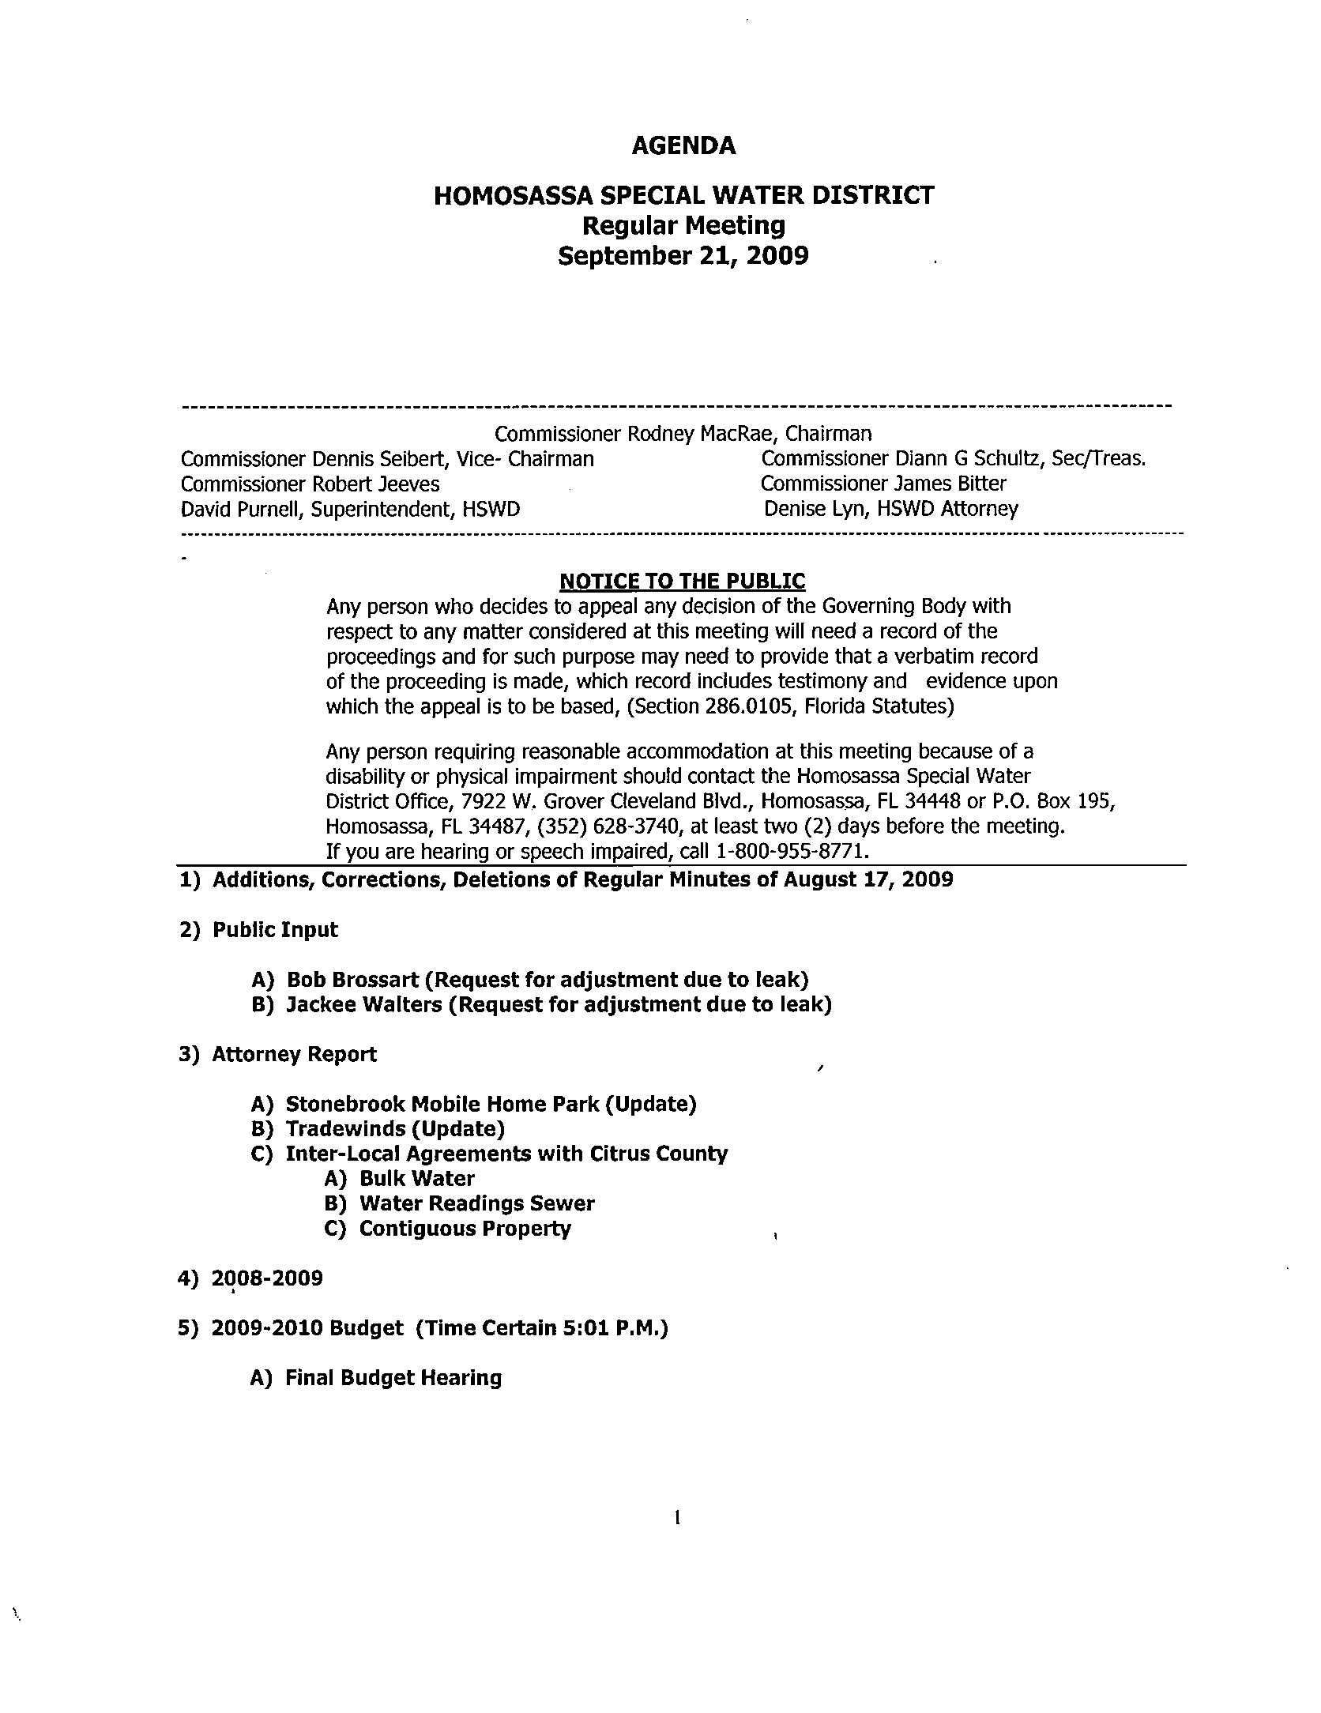
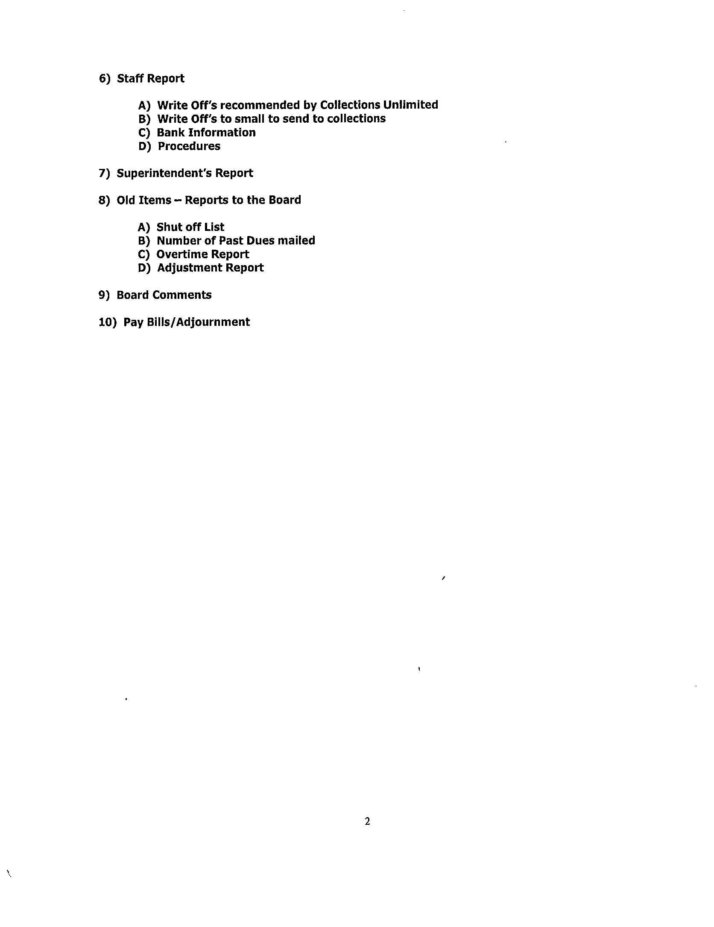

Homosassa Special Water District

REGULAR MEETING
September 21, 2009

A regular meeting of the Board of Commissioners of the Homosassa Special Water District was held on Monday, September 21, 2009 at the Water District office located at 7922 W. Grover Cleveland Blvd., Homosassa, FL.

Present were:

Commissioner MacRae Denise Lyn, HSWD Attorney
Commissioner Schultz David Purnell (Superintendent)
Commissioner Seibert Teresa Olds (HSWD)
Commissioner Jeeves Alvie Baker (HSWD)
Commissioner Bitter

Commissioner MacRae called the meeting to order at 3:00 p.m.

1) Additions, Corrections, Deletions of the Minutes of the Regular Meeting of
August 17, 2009 & Minutes of the Tentative Budget Hearing of September 3, 2009
(on file)

Commissioner Bitter made a motion to accept the Minutes the Regular Meeting of
August 17, 2009 as presented. Commissioner Jeeves seconded. Vote yes. Motion carried.

Commissioner Seibert made a motion to accept the Minutes of the Tentative Budget Hearing of September 3, 2009. Commissioner Jeeves seconded. Vote yes. Motion carried.

2) Public Input

A) Bob Brossart (Request for adjustment due to leak) (on file)

Discussion.

Commissioner Seibert made a motion to waive the conservation rates for the months of July and August. Commissioner Jeeves seconded. Vote yes. Motion carried.

B) Jackee Walters (Request for adjustment due to leak) (on file)

Discussion.

Commissioner Jeeves made a motion to waive the conservation rates for the months of July and August. Commissioner Schultz seconded.

Commissioner Seibert and Commissioner Bitter would like to see the month of June included.

Commissioner MacRae called for the vote on the motion.

Commissioner Schultz vote yes. Commissioner Bitter vote no. Commissioner Jeeves vote yes. Commissioner Seibert vote no. Commissioner MacRae vote no.

Motion dies.

Commissioner Bitter made a motion to waive conservation rates for the months of June, July and August. Commissioner Seibert seconded.

Commissioner MacRae called for the vote on the motion.

Commissioner Schultz vote yes. Commissioner Bitter vote yes. Commissioner Jeeves vote no. Commissioner Seibert vote yes. Commissioner MacRae vote yes. Motion carries.

3) Bid Opening- Elevated Tank Controls (Superintendent Purnell & George McDonald)

Commissioner MacRae opened the only bid received. Marolf Environmental Inc.
total bid $87,623.00.

Discussion with George McDonald on the bid that was received and the lack of bids.

4) Attorney Report

A) Stonebrook Mobile Home Park (Update-Superintendent Purnell & Attorney Lyn)

Discussion.

We are still looking at the negotiating phase of the agreement. Still working with American Land Lease Attorney’s on the wording of the agreement.

One issue, American Land Lease is wanting a figure for the 8” line that they are paying for a “not greater than” figure. American Land Lease is paying for the 8” line and the District will be providing the water meters.

Discussion.

Board agrees for George McDonald to proceed with the permitting portion of the Stonebrook Project.

Discussion.

Board directs Attorney Lyn to start the process of getting an easement from Mr. Whetstone.

B) Tradewinds (Update)

Attorney Lyn sent a letter to the owner.

C) Inter-Local Agreements with Citrus County
A) Bulk Water
B) Water Readings Sewer
C) Contiguous Property

Attorney Lyn will work on updating these agreements along with updating costs involved.

8-2 Superintendent’ Report –Elevated Tank

George McDonald discussed with the Board the elevated Tank and the validity of keeping the tank and the costs involved in maintaining the tank.

Commissioner Schultz made a motion to reject the bid received from Marolf Environmental Inc. and rebid project running ad in Trade Magazines and newspapers. Commissioner Seibert seconded. Vote yes. Motion carried.

5) 2008-2009 Budget (on file)

No Discussion.

6) 2009-2010 Budget Hearing (Time Certain 5:01 P.M.)

A) Final Budget Hearing

7) Staff Report (on file)

A) Write off’s recommended by Collections Unlimited (on file)

Commissioner Bitter made a motion to write off the accounts recommended by Collections Unlimited. Commissioner Jeeves seconded. Vote yes. Motion carried.

B) Write off’s too small to send to collections (on file)

Commissioner Schultz made a motion to write off the accounts too small to go to collections. Commissioner Seibert seconded. Vote yes. Motion carried.

C) Accounts going to Collections Unlimited (on file)

Commissioner Schultz made a motion on the accounts that are going to Collections Unlimited. Commissioner Seibert seconded. Vote yes. Motion carried.

D) Bank Information

Commissioner Schultz made a motion for staff to check with SunTrust Bank and Regions Bank to see if we could get an interest rate of 2% or greater on CD’s and up to 2 CD’s in the amount of $250,000.00 each. Commissioner Jeeves seconded. Commissioner Schultz amended motion to read any bank with 2% or greater staff to contact Chairman. Commissioner Jeeves amended his second. Vote yes. Motion carried.

E) Procedures (on file)

Discussion.

Board directed staff to add more information. Board approved the concept.

F) Web Hosting (on file)

Discussion.

Commissioner Seibert made a motion to accept Nature Coast Web & Design pursuant to the quote dated July 17, 2009. Commissioner Bitter seconded. Vote yes. Motion carried.

8) Superintendent’s Report (on file)

Discussion.

8-5 Directional Bore Machine

Discussion.

Commissioner Schultz made a motion to purchase the Directional Bore Machine from Vermeer for $79,984.00. Commissioner Seibert seconded. Vote yes. Motion carried.

8-3 Mickey’s Point

Discussion.

Board recommended changes to the letter to Mr. Fields and also to send a colored aerial picture of the property and easement. Attorney Lyn made changes to the letter during the Board Meeting. Board agreed with the changes made to the letter.

9) Old Business – Reports to the Board

A) Shut off List (on file)
B) Number of Past Due’s mailed (on file)
C) Overtime Report (on file)
D) Adjustment Report (on file)

10) Board Comment

11) Pay Bills/ Adjournment

Commissioner Seibert made a motion to pay bills and adjourn the meeting.
Commissioner Jeeves seconded. Vote yes. Motion carried.

